Evaluating the Deployment of Microclimate Prediction Models On Embedded Systems

# **Abstract**

# This paper explores the feasibility of utilizing powerful machine learning models for microclimate modelling andprediction in extremely remote environments. The experiments outlined in this paper simulate rigid constraints on economic cost, computing power, and Internet connectivity in order to draw comparisons to real-world settings such as isolated farms or offshore environments, where weather prediction is often critical, but resource constraints make it exceedingly difficult. Cost and computing constraints are considered through the use of an inexpensive STM32F767 board which hosts only 2MB of flash memory and 512KB SRAM. The paper examines the trade-offs between model accuracy, computing power, and inference latency. Two custom neural network architectures are designed, built, trained, pruned and quantized to minimize resource usage, and subsequently deployed to the board, situatedin a rural area close to city of Couva, Trinidad and Tobago. The various model performances are then evaluated and compared. Finally, as we aim to demonstrate the feasibility of deploying sufficiently accurate models within these resource-constrained settings, the performances of the pruned and quantized models are evaluated against full-sized models deployed in the cloud, highlighting that stellar performance can be achieved despite rigorous hardware constraints.

Word count (excluding references): 7989

# **Keywords**

TinyML, Embedded Systems, Microclimate, Machine Learning, EdgeAI, Caribbean Climates

# **Introduction**

## Background to Weather Forecasting

Accurate weather forecasting plays a critical role in numerous tasks across various aspects of modern society. Weather forecasts heavily influence individual decision-making: the type of clothing worn, outdoor activities planned, and the mode(s) of transportation chosen for travel.

On a larger scale, these forecasts become even more crucial. In power demand forecasting, for example, Diaz-Iglesias et al. demonstrated that weather variables significantly impact the need for heating, cooling and lighting in a population, thus highlighting the close correlation between weather forecast patterns and energy consumption patterns. In the field of agriculture, Shen et al. found a positive correlation between the frequency at which agricultural producers tracked meteorological forecast information, and their subsequent income growth (2024). In the field of offshore installations and maintenance as well, Døskeland et al. highlighted how industrial work performed close to offshore platforms or subsea infrastructure is often very sensitive to weather, and how decisions made around weather forecasts could have serious Health and Safety (HSE) and economic ramifications (2023).

Historically, weather forecasting has been achieved primarily through the use of Numerical Weather Prediction (NWP). Predictions are obtained by numerical integration of partial differential equations to determine the current state of the Earth’s atmosphere (Ben Bouallègue et al., 2024). These equations to model the physical laws of fluid dynamics and thermodynamics were first introduced in the early 20th century. Since then, there have been periodic, incremental improvements in NWP through advancements in supercomputers, numerical modelling and other techniques. Forecast accuracy can be increased by raising the resolution of the model (through reducing time steps or decreasing grid spacing), however, limitations are quickly imposed by high computational and timeline costs (de Burgh-Day and Leeuwenburg, 2023).

Additionally, NWP models generally work best at larger spatial scales rather than very localized microclimates. Microclimates describe climatic parameters (such as temperature, humidity and precipitation) in and around a homogenous, smaller zone of interest. As highlighted by Kumar et al. (2021), commercial weather stations (which capture the data used by these NWP systems) are often located a significant distance away from regions of interest, leading to degradations in climatic patterns and poor forecasting performance in particular microclimates.

Improving forecasting capabilities within these microclimates could result in substantial economic gains in an assortment of fields such as those highlighted above: offshore-platform activity planning, commercial fishing scheduling, and large-scale agricultural crop rotations.

## The Impact of Machine Learning

Data-driven Machine Learning (ML) solutions are being increasingly recognised for their potential in this space, as they are able to deliver these predictions with much lower computational costs. As the amount of publicly-available weather datasets grows, so too does the viability of weather forecasting ML solutions. For example, the European Centre for Medium-Range Weather Forecasts (ECMWF) publishes and maintains a massive open dataset of hourly estimates for global weather data (Copernicus Climate Change Service and Climate Data Store, 2018). Dueben and Bauer were able to utilize this dataset to create several Neural Networks (NNs, one type of ML model available), which was able to forecast weather in a 24-hour timeframe reasonably well (2018).

The recent explosion of research into NNs has given rise to a myriad of model architectures which propagate input data through multiple layers, with each layer progressively extracting higher level features from the data.

## General Architecture of Neural Networks

The figure below illustrates the architecture of a basic NN. In this example, we have 3 input nodes (which represent 3 features of input data). These 3 input nodes are all connected to 4 hidden nodes (which perform computations on the data to learn its features and patterns), and finally, these are connected to 2 output nodes (which will produce a label or prediction for our input data).



Figure 1: Basic feedforward neutral network architecture (adapted from Goodfellow et al., 2016)

To draw on this illustration, if we were to utilize an architecture such as this to forecast weather, the 3 features being passed to the input nodes could be imagined as temperature, humidity and pressure (with all these data collected via sensors), and the output nodes (the target variables) could be temperature and humidity.

NN architectures with several hidden layers are commonly termed Deep Neural Networks (DNNs) and are encapsulated within the field of Deep Learning (DL). These have been shown to be excellent at learning features of the input data, enabling better eventual predictions or classifications than traditional ML approaches (Shiri et al., 2023). Within this broad class of DNNs, there exist subclasses such as Multi-Layer Perceptrons (MLPs), Convolutional Neural Networks (CNNs), Recurrent Neural Networks (RNNs) and Long Short-Term Memory (LSTM) models, with each subclass having their own unique set of computational strengths and being better suited to different tasks.



Figure 2: The hierarchical relationship between several major ML classes, adapted from Shiri et al. (2023).

Lara-Benítez et al. compared the performance of seven popular NN architectures, including MLPs, CNNs and RNNs, in time-series forecasting tasks across twelve datasets (2021). After statistical analyses of each architecture in each dataset, they found that the MLPs generally performed the worst, that the RNNs obtained high accuracy in forecasts at the cost of high training and inference time, and that the CNNs had the highest efficiency in terms of time-accuracy trade-offs.

Typically, all of these ML models are run in large datacentres, on cloud servers. These cloud servers often include powerful Central Processing Units (CPUs) alongside multiple Graphical Processing Units (GPUs), each equipped with several gigabytes (GBs) of memory. This is necessary because these models require large amounts of memory, memory bandwidth, and parallel computing power to handle speedy, high-dimension matrix operations. This, in turn, translates to high power demand by these servers (commonly several hundreds of Watts,W) alongside high operational and maintenance costs. Additionally, it means that all systems that incorporate these models must configure and maintain one (or more) Internet connections (which can be pricey and/or slow, depending on the environment), and must accept the high latency and privacy risks incurred during network communication with these cloud servers.

## ML on Embedded Devices

In recent times there has been growing interest in deploying these models on low-power computer systems with dedicated functions within larger electrical or mechanical systems. These are commonly termed embedded devices, and often take the form of Microcontroller Units (MCUs). They are often optimized for low power consumption and cost, small sizes, and are usually deployed on the edge (i.e. close to where we produce and utilize the data) (Kelemen et al., 2020).

By running these models on these devices, we can provide better privacy and lower our bandwidth requirements (since we don’t need to transmit all of our data over the Internet), lower our power requirements (to several milliwatts, mW), and provide more real-time data processing (Han et al., 2015). This alternative way of running ML algorithms by using these low-profile devices is termed TinyML (Abadade et al., 2023). More specifically, TinyML refers to ML inference performed on edge devices that typically consume power in the milliwatt range, while devices that consume more than this fall into the broader class of Edge AI devices (Warden and Situnayake, 2019).

This deployment, though, requires these ML models to be highly memory-optimized and compressed so that they can fit on the on-chip SRAM (Static Random Access Memory) and flash memory, which are both ordinarily only a few megabytes (MB) or hundreds of kilobytes (KB) in size. In order to achieve this, researchers utilize techniques such as pruning and quantization, which are able to produce ML models at much lower sizes, but similar levels of accuracy. Pruning involves removing less important neurons and connections from the models, while quantization involves reducing the precision of weights and activations stored by the model. These techniques can enable compression ratios of up to 49x and memory footprint reductions greater than 90%, while maintaining similar levels of accuracy as the full models (Heydari and Mahmoud, 2025).

In the following section, we further examine research and analysis performed into deep neural network architectures, compression techniques employed on these architectures to enable TinyML, and specific use cases where these TinyML model architectures have been deployed.

# **Related Work**

## Background to Neural Networks and Dense Neural Networks

In this section, we will first review the foundational ideas and computations underpinning NNs, then further expand these ideas to understand the more sophisticated class of DNNs. We will focus solely on explaining these ideas in the domain of regression (i.e. the prediction of numerical values). NNs and DNNs can be used in many other domains such as classification, but that is outside the scope of this work.



Figure 3: The basic computations involved in a single neuron, adapted from (Sze et al., 2017).

In the above figure, Sze et al. (2017) illustrate a series of *n* input features of X, fed into a neuron. The *n* features represent different aspects of the input dataset, X, that were captured. For example, a weather dataset might have 3 input features: temperature, pressure and humidity (*n*=3 in this case).

The weights, *w*,represent multipliers that allow the NN to assign lower or higher importance to linear combinations of the input features.

The biases, *b*, are offsets that allow the NN to shift the output so that the function does not always need to pass through the origin.

The functions, *f*, are non-linear activation functions that transform the weighted sum. This allows NNs to closely approximate and model real-world functions. Common examples include the Rectified Linear Unit (ReLU) and Hyperbolic Tangent (tanh) functions.

The predicted output *Ŷ*, is then taken as the output of this activation function.

In supervised ML tasks, the true output *Y* for several input data points is labelled in advance, and the accuracy of the NN is computed by measuring the difference between the predicted output *Ŷ* and the true labelled output *Y*, using a loss function. There also exists another category called unsupervised ML, but that is outside the scope of this work.

Two main classes of loss functions are typically used, the Mean Absolute Error (MAE), and the Mean Squared Error (MSE).

MAE is mathematically defined as:

$$MAE=\frac{1}{n}\sum{\left|yᵢ-ŷᵢ\right|}$$

and for MSE:

$$MSE=\frac{1}{n}\sum{{\left(yᵢ-ŷᵢ\right)}^{2}}$$

Where $y_{i}$ ​ = true value, $ŷ_{i}$ = predicted value, $n$ = total number of samples

MAE computes the aggregation of the L1 losses, while MSE computes the aggregate L2 losses. In simple terms, the MAE gives an average of how far off the predictions are from the true values, while the MSE squares the prediction errors so that the differences are further amplified.

MSE is the most widely used for time series forecasting tasks, but both functions have their comparative advantages. For example, MSE is much more sensitive to outliers than MAE, and MAE is much quicker to compute (Jadon et al., 2024).

It can be observed that the computation of the predicted output for a neuron and the loss for that output involves several multiply and accumulate (MAC) operations. These MAC operations for the data points may occur millions of times across the entire NN. These operations typically dominate the computation cost of the NN architecture. The number of MACs is thus a common measure to benchmark the performance of an architecture, and becomes even more significant in the field of TinyML, where compute power is often severely limited.

In practice, *X*, *Y* (and *Ŷ*) are commonly vectors (i.e data represented by rows and columns), which allow the NNs to process large datasets with multiple dimensions using highly-parallelized computations.

These individual neurons can then be scaled to form *layers*. A single layer of a NN can be composed of hundreds or thousands of neurons, and DNNs can often have tens or hundreds of these layers. Due to the non-linearity of the activation functions, these large NN architectures have been found to be capable of learning high-level features of input data with significant complexity and abstraction, which allows them to perform advanced predictions of numerical values, recognise composite objects and even interpret entire scenes in images.



Figure 4: An example of an image classification task using a DNN, adapted from (Sze et al., 2017). Image is open-sourced from Unsplash.com

As discussed by Sze et al., two high-level stages are typically involved in all ML tasks. The first stage is termed the *training* stage, and involves randomly initializing the parameters (weights and biases) of the model, then splitting the input dataset into three parts to optimize these parameters using techniques such as gradient descent:

1. The training subset is used to improve these parameters by computing a loss (the difference between the estimated output from the model and the true output of the dataset).
2. The validation subset is used to tune hyperparameters for the model (which control things such as the speed at which the model updates its parameters) and prevent overfitting (ensure that the model is generalizable to all future data, and doesn’t just perform well on this input dataset).
3. The testing subset is used to provide an unbiased estimate of the performance of the model, using data that the model has never seen before, so that it can be compared fairly to other models.

This training stage is usually computationally-heavy and time-consuming, and is thus usually performed on the cloud. The output of this first stage is our trained model, which consists of a series of weights and biases along with the activation functions, all arranged in the particular NN architecture (measured primarily by its total MACs).

The second stage is called the *inference* stage, where the trained model is utilized to predict new datapoints, and it is on this stage that optimized computation is essential, to ensure that the models run smoothly on low-power, embedded devices.

## Efficient Neural Networks and TinyML

Typically, increasing the capability of the model necessitates increasing the size and complexity of the DNN architecture. The table below illustrates the computation costs of some popular DNN architectures, when used for a particular image classification challenge called ImageNet.

|  |  |  |  |  |  |
| --- | --- | --- | --- | --- | --- |
| **Metric** | **AlexNet** | **Overfeat fast** | **VGG 16** | **GoogLeNet v1** | **ResNet 50** |
| Error rate | 16.4% | 14.2% | 7.4% | 6.7% | 5.3% |
| Total Weights | 61M | 146M | 138M | 7M | 25.5M |
| Total MACs | 741M | 2.8G | 15.5G | 1.43G | 3.9G |

Table 1: An illustration of some typical DNN architectures with their metrics, adapted from Sze et al. (2017)

In this table, we can see that, with some exceptions, the capability and complexity generally increase from left to right, and the error rate decreases (i.e. the accuracy increases) in the same manner. The higher number of weights translate directly to higher memory requirements, and the heightened MACs translate to greater processing time. Both translate to a much greater energy requirement for inference in the model.

However, researchers have found several techniques to reduce these weight and MAC requirements, while keeping the accuracy of the model approximately constant. The two main techniques we will delve into are pruning and quantization.

As presented by Abadade et al., pruning a NN involves setting a particular threshold for weights and eliminating those weights below that chosen level. In this manner, only the most significant weight contributors (most important neurons) are kept in the model. There is an initial loss of accuracy, but this can be easily restored through retraining of the sparse NN (as opposed to the initial dense NN) (2023).

Cheng et. al expanded on this by first explaining that pruning could be broadly divided into two classes: unstructured and structured pruning (2024). Unstructured pruning refers to the removal of weights anywhere in the network (in individual neurons), while structured pruning conducts pruning across entire filters, channels or layers. They advised that without special hardware or software libraries, structured pruning was more suitable in most cases because of the complexity in implementing unstructured pruning.

Quantization is also presented as a technique to reduce the precision of weights and activations in the NN architecture. Instead of representing these as 64-bit or 32-bit floating-point numbers, quantized models represent these parameters as 8-bit fixed-point numbers or other, more-efficient schemes.



Figure 5: : A simple visual illustration of pruning and quantization of a subset of neurons

Abadade et al. also discussed several other techniques for compressing these DNNs such as huffman coding and knowledge distillation, but we chose to focus mainly on pruning and quantization as they were the best supported in standard application and tooling environments (2023).

In the next section, we briefly explore some past studies where TinyML devices have been deployed in the field.

## TinyML and EdgeAI Case Studies

Codeluppi et al. performed an extensive experiment on running ML models on edge AI devices, by creating and analysing Long Short-Term Memory (LSTM) networks, Recurrent NN (RNNs) and Artificial Neural Networks (ANNs) (i.e. Multilayer Perceptrons, MLPs) deployed on a Raspberry Pi device (2021). These NNs were used to predict air temperature inside a greenhouse (in its microclimate), and were chosen as they were found in the literature to be particularly good at time-series forecasting.

The authors highlighted how climate variables inside a greenhouse are critical to its commercial operation, as the growth rate of the products being grown depend on variables such as soil moisture, air humidity and temperature. They mentioned that this makes greenhouses one of the best use-cases for such a ML model, as the outputs of the model can be directly connected to actuators to regulate the temperature, which in turn directly improves revenue for the greenhouse operation.

They found that the RNN and LSTM models resulted in the highest performance, with the lowest root mean squared errors (RMSE) of 0.289 and 0.294 **°**C respectively.



Figure 6: Possible application scenario for DNNs in a greenhouse microclimate, adapted from (Codeluppi et al., 2021)

Deutel et al. studied DNN implementation on ARM Cortex-M-based systems, utilizing pruning and quantization to compress the models for these TinyML devices (2022). They mainly focused on a proprietary compression pipeline that they created, but illustrated that the performance was comparable to a standard pipeline involving Keras, TensorFlow and TFLM.

They utilized a Raspberry Pi Pico and an Arduino Nano 33 BLE Sense, which both come equipped with only 256 Kilobytes of SRAM and one or two megabytes of flash memory. They were able to compress popular DNN architectures such as LeNet, AlexNet and ResNet to enable them to be run on these miniscule amounts of RAM.

|  |  |  |  |
| --- | --- | --- | --- |
| **Model** | **Compression Ratio** | **Equivalent Memory Reduction** | **Relative Accuracy** |
| LeNet | > 99 % | Model size reduced by > 100× | > 99 % |
| AlexNet | > 98 % | Model size reduced by ~50× | ≈ 95 % |
| ResNet | ≈ 93 % | Model size reduced by ~15× | ≈ 96 % |

Table 2: Summary of DNN model compression, adapted from (Deutel et al., 2022)

The table above summarizes the results that the authors were able to achieve. In all cases, they found that increasing the compression ratio decreased the execution time required for inference, but also decreased the relative accuracy. Thus, there was a trade-off between maximum tolerable execution/inference time and minimum tolerable accuracy.

# **Materials and Methods**

For our own research, we set out to build a system capable of forecasting outdoor air temperature in a rural area near Couva (a city in Trinidad and Tobago), using ML on a simple, low-power embedded system.

As illustrated below, we first set up several sensors to record and log ambient environmental data at the location, after which we pre-processed the data and set out building the full ML model.

Once the model was built, we pruned, quantized and evaluated the model, before deploying it on our embedded board. We then analysed the performance of the deployed model while performing inference, and stepped back to ML model building to fine-tune the architecture and hyperparameters of the model as required to improve our results.



Figure 7: The overall process that we used to guide our experiment

We dive into more detail of each step in the following sections.

## Sensor Data Collection

We utilized three sensors to collect the local environmental data that we needed for the initial training:

* A BME280: To measure temperature, humidity and pressure
* A VEML7700: To measure light intensity
* A LM393: To measure whether it rained or not

Unfortunately, the LM393 sensor (which monitored whether rain was falling or not) was found to produce unreliable data, so it was excluded from all further stages.

Besides these sensors, two other modules were required in order to build the dataset accurately:

* A DS3231 Realtime Clock (RTC) module: To maintain an accurate internal clock for timestamps
* A MicroSD Breakout Board and MicroSD card: To store the periodic measurements from the sensors

An STM32 F767 board was used as the core of the system. The following figure illustrates the physical connections between these modules and the board:

Figure 8: Physical connections between the modules discussed and the STM32 board

Several small breadboards and jumper wires were used to make the physical connections. The board was configured through STM32 Cube IDE with the FreeRTOS operating system to coordinate tasks for each module.

Figure 9: Simplified View of the State Machines of Modules Coordinating Data Collection

The above figure illustrates a simplified version of the state machines configured for the main modules of the system. Each sensor ran in its own Task (or thread), and put its valid results onto the measurement queue every ten minutes. The measurement task initialized the file system, directory and daily log file on the MicroSD card, then serviced the queue and flushed the recorded data (with their timestamps) to the daily csv log file.

Figure 10: An illustration of the csv data persisted to disk

The figure above shows a snippet of the data that was collected in a single CSV file.

In the following section, we discuss how we aggregated, cleaned and standardized data from the entire collection of files.

## Data Preprocessing

Several data pre-processing steps needed to be implemented on the raw CSV sensor data before it could be used to train our ML models. Figure 11 illustrates these steps.



Figure 11: An overview of the data preprocessing stage

### Data Aggregation

Since each CSV represents one 24-hour period of environmental sensor data, the foundational step in preparing the data for our ML models involved concatenating all CSVs into a single, unified dataset. This concatenation made it far simpler to perform downstream data processing steps, and to pass the full dataset to the ML models.

Figure 12: Aggregating daily CSV files into a unified dataset

### Pivoting and Reshaping

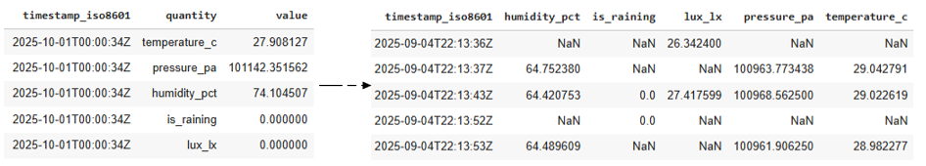

Figure 13: Pivoting the unified dataset, ensuring each feature is a column

ML models typically require one row of data to represent one instance of the dataset. For our timeseries forecasting task, this means that each row should indicate the state of each feature at that timestamp. Pivoting the unified dataset ensured that for each timestamp, the value of each feature is represented as a column (Figure 13 RHS), as opposed to one row representing one feature’s value at each timestamp (Figure 13 LHS).

### Resampling

Resampling involves converting a sequence of data points from one sampling rate to another. The right-hand side of Figure 14 indicates why resampling was a necessary data preprocessing step in our methodology. Since our initial timestamps go down to the granularity of seconds, if there is a slight difference (a few seconds) between the time the BME280 sensor captures humidity, pressure and temperature readings, and when the VML7700 sensor captures light intensity, this will be represented as two separate rows (e.g. 2025-09-04T22:13:36Z and 2025-09-04T22:13:37Z). In practice, we intend for these readings to represent values for the same time period, thus, we must resample to a less granular interval. We resampled the data from 1-second intervals to 30-minute intervals. Within each 30-minute interval, there are up to 1800 readings from each sensor, so to get one representative value for the resampled 30-minute interval, we take the mean of all the 1-second interval values within a given 30-minute interval.

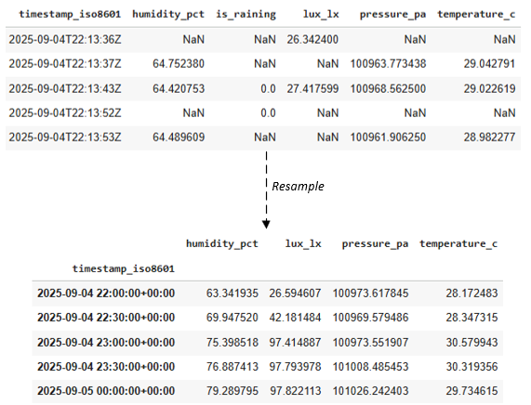

Figure 14: Resampling from a 1-second interval to a 30-minute interval

### Interpolation

During the data collection period, the sensors did not always capture data continuously. Periodic interruptions, such as those required for additional configuration or maintenance, necessitated temporarily disconnecting the board and sensors from power. As a result, some 30-minute intervals contain no recorded measurements. To address these gaps and maintain a consistent time series for input into the ML models, we applied interpolation techniques to estimate missing values within these intervals. To achieve this, we used simple linear interpolation; for each missing value, we find the nearest valid data point before and after the gap, then estimate the missing value and a point on the straight line connecting the two known values. This process is done independently for each feature.

Figure 15: Temperature and Humidity Dataset Before and After Interpolation

### Feature Engineering

Several custom features were engineered from the raw sensor data to enhance the predictive performance of the ML models.

* Cyclical Time Features:  
  The sine and cosine of the hour of the day were computed to capture daily periodicity and represent time as cyclical variables. This ensures that times such as 23:00 and 0:00 are recognized as much more temporally adjacent than, say, 23:00 and 15:00, thus capturing relevant diurnal cycles.   
  The sine of the hour of day is calculated as: $$sine_hour = \sin\left(2π\frac{h}{24}\right)$$ 
  The cosine of the hour of day is calculated as: $$cosine_hour = \cos\left(2π\frac{h}{24}\right)$$
* Temperature Delta:   
  For each timestamp, the difference between the current temperature and the temperature at the previous timestamp was calculated as $ΔT_{t}=T_{t}-T_{t-1}$ where: $ΔT_{t}$ 
   is the temperature delta at time T. $T_{t}$ is the temperature at the current timestamp $T_{t-1}$ is the temperature at the previous timestamp  
    
  This provides the model with information about shorter-term temperature changes, enabling prediction of rapid fluctuations in weather conditions.
* Rolling means:   
  6-hour rolling averages were computed for temperature and humidity to provide context on recent trends. $${\overline{X}}_{t}=\frac{1}{N}\sum_{i=0}^{N-1}{X_{t-i}}$$ 
  where: $\overline{X_{t}}$ 
   is the rolling average at time t $X_{t-i}$ is the value of the variable at time t - i $N$ is the number of time steps in 6 hours (for 30-minute intervals, N = 12)

### Normalization

We used Z-score normalization (standardization) to scale every feature except the target feature (temperature) into a common scale, without distorting differences in value ranges.

The Z-Score for each feature is calculated as:

$X'=\frac{x-μ}{σ}$.

In the context of our experiments, the initial features in the raw data had significantly different scales. Normalization ensured that each feature contributed equally to the learning processes of the ML models, i.e. this prevented larger ranges from dominating. Additionally, Cabello-Solorzano et. al demonstrated that Z-score normalization improves accuracy across multiple ML algorithms, including neural networks (2023). Figure 16 highlights the difference in the scale of the humidity feature before and after Z-score normalization.

Figure 16: Illustration of input feature normalization

As illustrated, the distributions of values across multiple features are more evenly spread after normalization, resulting in the model applying more equal weights to each feature.

### Windowing for Time Series

For this time series forecasting task, the data was structured into fixed-length input and output sequences. Each input sequence was comprised of a 24-hour sequence of historical observations, while the corresponding output sequence represented the subsequent 12 hours of temperature forecasts. (i.e. we used the previous 24 hours to predict the next 12 hours of temperature). Since we resampled to 30-minute intervals, this meant that 48 instances were used to compose each input window, and 24 instances were used to compose each output window.

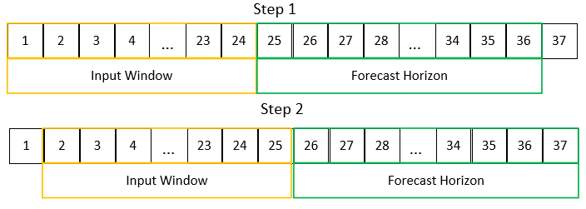

Figure 17: Examples of input and output interval slots used for windowing

## Supplemental Data Collection

Unfortunately, we were only able to collect approximately 2 months of valid sensor data from local sensors in the rural location in Couva. We therefore used the OpenMeteo Historical Application Programming Interface (API) to augment our sensor data to create a full year of overall training data. In order to match the sensor data, we used the following features available from the API:

* **Temperature** (Air temperature at a 2 meters elevation above the ground)
* **Relative Humidity** (Relative humidity at a 2 meters elevation above the ground)
* **Shortwave Radiation** (Shortwave solar radiation, a proxy for light intensity)
* **Surface Pressure** (Atmospheric air pressure reduced to pressure at surface)

Once the input dataset was downloaded, the same preprocessing steps discussed above were performed. The two datasets were then merged to form the complete training dataset.

## ML Model Building

### Convolutional Neural Network

Since our literature review showed that CNNs were a good choice for a balance between model forecasting performance and hardware resource constraints, we decided that it would be a suitable first architecture for our use case.

Figure 18: The CNN architecture we created to forecast temperature for a 12-hour window

Our input layer consisted of a feature vector of size [1x48x7], with the first dimension (1) representing a single batch of time sequences (in 30min batches), the second dimension (48) representing the historical size of the time slots in the window, and the third dimension (7) representing the number of features of our input data used in each time step.

The input layer fed into the first convolutional block, which consisted of 2 convolutional layers followed by a max pooling layer. The first convolutional layer consisted of 24 filters with a kernel size of 5 and a ReLU activation function, allowing the model to learn low-level temporal patterns across all the input features over a series of 5 time-steps, while keeping the length of the time-axis constant.

The second convolutional layer consisted of 24 filters with a kernel size of 3 and a ReLU activation function, enabling the model to learn higher-level patterns about our data by extending the first layer’s representations. The max pooling layer then computed the maximum across every 2 time-steps, reducing the temporal size of the feature maps produced by the convolutional layers, thereby ensuring that the computational cost of the following layers remained manageable.

The data then flowed into a second convolutional block, beginning with two separable convolutional layers. Both of these consisted of 64 filters with a kernel of size 3 and ReLU activation layers as well. These layers broke standard convolutional (as performed in the first layers) into depthwise and pointwise operations, examining features along each channel independently, then mixing the channels together in a linear combination. This allowed us to create more channels for richer representations of patterns across the training data, while keeping the number of parameters and MACs lower than a standard convolutional layer. These were very applicable at this stage in the CNN because each convolutional layer produced a large number of output channels to represent the features learned.

The data then flowed to another max pooling layer (to compute the max across every 2 time steps again), and then a global average pooling layer, which computed averages of each feature map learnt (i.e. the new channels learnt in the previous steps) across the temporal axis, allowing us to find significant features while keeping the number of parameters comparatively low.

We then introduced a dense projection layer with 96 units, which combined the features learnt in the previous steps to find patterns and relationships among the past feature data to determine the most appropriate forecast values for the future.

The dropout layer prevented overfitting (a phenomenon where models become too closely tied to their training dataset and thus perform poorly on other, newer datasets) by randomly assigning 10% of the weights in the model to 0.

Finally, the dense output layer produced our forecasted temperature values, with the number of output units equal to 24 for our final testing, allowing us to forecast 12 hours of data (24 forecast slots, each at 30 min time intervals).

### Recurrent Neural Network

Much of the deep learning literature also suggested that RNNs were a strong candidate model for the use-case presented in this paper, as RNNs are a class of neural networks specifically designed to process sequential data (Rumelhart et al. 1986). Unlike a regular feedforward neuron or a convolutional neuron, a recurrent neuron receives inputs, produces an output, and sends that output back to itself. At each time step $t$, the recurrent neuron takes the current input $x_{\left(t\right)}$, and its own output from the previous time step ${\hat{y}}_{\left(t-1\right)}$. To determine the RNN architecture, we employed a randomized search methodology which found the combination of hyperparameters which minimized the MAE of the model. To perform this random search, we specified the search spaces for the hyperparameters in Table 3. Table 3 also shows the results of this random search.

|  |  |  |  |  |
| --- | --- | --- | --- | --- |
| **Hyperparameter** | **Hyperparameter Description** | **Purpose** | **Search Space** | **Optimal Value** |
| n_hidden | Specifies the number of additional recurrent layers stacked after the first RNN layer | Controls depth of temporal feature extraction | $$ϵ \{0,1,2,3\}$$ | 1 |
| n_neurons | Defines the number of neurons in each additional recurrent layer | Determines model’s capacity to learn complex patterns | $ϵ[16, 64]$ (integer) | 27 |
| optimizer | The algorithm used to update model weights during training | Influences convergence speed | $ϵ$ {sgd, adam} | adam |
| learning_rate | A scalar value that controls the step size during gradient descent | Balances convergence speed against the risk of overshooting loss function minimum | $ϵ\left[1e-4,1e-2\right]$ (log) | 0.00905 |

Table 3: An overview of the hyperparameters describing the architecture of the final model

The input layer accepted a sequence length of 48 instances (*48 time steps = 24 hours at 30-min sampling rate*). Layer 1 is a SimpleRNN layer with 32 neurons. This layer extracted temporal features, then passed the full sequence to Layer 2. Layer 2 is another SimpleRNN with 27 neurons, as determined via the optimization performed by the randomized search. Finally, the output layer provided a linear projection to the 24 time-step temperature forecast horizon (*24 time steps = 12 hours at 30-min sampling rate*).

Figure 19: The final RNN architecture

## ML Model Pruning & Quantization

Figure 20: Our pruning process to reduce the space and computations of the initial full model

To compress our model, we then implemented structured pruning as described in the figure above.

Instead of trying to prune individual weights, entire channels were pruned by computing their L1 norms. The L1 norm allows us to calculate a simple scalar number that represents the relative important of a channel in a CNN layer, and is defined as:

$$|w|_{1}=\sum_{i=1}^{n}{\left|w_{i}\right|}$$

Where $|w|_{1}$ is the L1 norm and $n$ is the number of weights in a particular channel

Channels/filters with lower L1 norms can be interpreted as being less important to the overall model, and are thus good candidates for pruning.

For each layer, we defined a keep ratio, specifying what percentage of channels we wanted to keep. The earlier layers in each model were given higher keep ratios as they were found to be more crucial for feature mapping.

Several candidates of keep ratios were then configured, with progressively more aggressive pruning for each candidate. Each candidate was then assessed in terms of both MAE increase as well as size and computation decrease, to determine which one produced the best overall result.

Once the pruning was completed, we realigned the layers to ensure that the dimensions were correct within and between each layer.

At this point, the model consisted of weights and activations represented by 32-bit floating point numbers. To reduce its size and computational complexity even further, a large subset of the training and validation data were assessed to determine their full dynamic range and thus calculate appropriate step intervals. These steps were then utilized to quantize the weights and activations to 8-bit integer values, which are much easier for the majority of microcontrollers (like our STM32) to manage.

Additional functions were also added to normalize and quantize the input and output data values passed to and from the model, so that all MAC operations could be done with solely integers.

## ML Model Deployment

The quantized model was then loaded into STM32 Cube.AI package for conversion into a C library, so that it could be integrated with the rest of the FreeRTOS code. Tasks were then created to perform inference on the system, and to log the results to the MicroSD card for analysis.

Figure 21: The Forecast Temp Task which handled the bulk of the inference work on the board

The first task, named the **Forecast Temp Task**, is illustrated above.

At startup, pointers were initialized to the input and output buffers of the model. The SD card was then mounted in the filesystem, and past measurements were used to partially reconstruct the 24-hour window, so that we didn’t need to wait 24 hours to get an inference reading on each reboot of the board.

The latest data from the sensors were then fetched every 1 minute, until we had a full 30-min window of sensor samples. Once this 30-min window was filled, the extra engineered features were also computed. Then all 9 features were normalized and pushed onto a new slot in the 24-hour inference window.

This occurred repeatedly until the 24-hour window was filled. At that point, the entire window was quantized and exported, then fed into the model produced by STM32 Cube.AI. The output of the model was then denormalized and dequantized to get the true inferred value for temperatures.

The array of 30-min inferred values, for the upcoming 12 hours of temperature predictions were then stored in a context variable for reading by other tasks.

Figure 22: The Inference Logger Task which handled the periodic logging to the MicroSD card

The second task, called the **Inference Logger task** handled the reading of the latest predicted/inferred values from the Forecast Temp Task and its writing into the SD card. Upon initialization, the task ensured that the SD card was mounted in the filesystem and the expected directory was created. It then created an inference CSV file to store all inference values recorded in a single day.

Every 5 mins, this task then polled the Forecast Temp Task for the current cached inference value, and wrote it to the current daily CSV. The task also managed error conditions and daily file rotations.

## Power and Inference Time Measurement

We implemented a simple system to compute an approximation for the inference time for each model, by recording the time before the Forecast Temp Task was called, then the time after the function call was completed. The inference time (in ms) was taken as the difference between both.

We also implemented a simple system to approximate the total power draw of the embedded system by utilizing an in-wall multimeter, and sampling the AC voltage, current and power factor in 5-min intervals.

# **Results and Discussion**

## Model Compression

The following table summarizes the compression we achieved for each model.

|  |  |  |
| --- | --- | --- |
|  | **CNN** | **RNN** |
| Initial model size (kBs) | 49.72 | 105.91 |
| Initial number of parameters | 12,728 | 19,032 |
| Initial number of MACs | 200,064 | 644,652 |
| Initial test MAE (°C) | 1.38 | 1.63 |
| Model size after pruning (kBs) | 46.53 | 102.05 |
| Number of parameters after pruning | 11,911 | 18,943 |
| Number of MACs after pruning | 169,272 | 644,563 |
| Test MAE after pruning (°C) | 1.34 | 1.68 |
| Model size after quantization (kBs) | 30.77 | 80.88 |
| Number of parameters after quantization | 11,911 | 18,943 |
| Number of MACs after quantization | 169,272 | 644,563 |
| Test MAE after quantization (°C) | 1.44 | 1.70 |

Table 4: Summary of model compression after each stage

For the CNN, we saw that the model size was reduced by 6.4% after pruning, and a further 38.1% after quantization. The number of parameters and number of MACs were both also reduced by 6.4% after pruning, and stayed consistent after quantization. We actually saw a slight decrease in MAE after pruning (-2.9%), but then this was followed by a 4.3% increase in MAE after quantization.

For the RNN, we saw that the model size was reduced by 3.6% after pruning, and a further 23.6% after quantization. The number of parameters and number of MACs were both also reduced by 0.5% after pruning, and stayed consistent after quantization. We saw an increase in MAE after pruning of 3.1%, followed by a 1.2% increase in MAE after quantization.

Comparing the RNN to the CNN, we saw that the final model size ~2.6x higher, the number of parameters was ~1.6x higher, and the number of MACs was ~3.8x higher.

## Model Performance

The inference data for both models was collected from the embedded system and visualized below. In order to measure the inference error, the predicted temperature at $t+1$ hour was retrieved from 3 days of inference files. This was plotted against the true measured temperature from sensors on the same embedded system. The difference between both plots was computed and visualized independently as the prediction error. Additionally, the inference latency was graphed for each model.

## Convolutional Neural Network

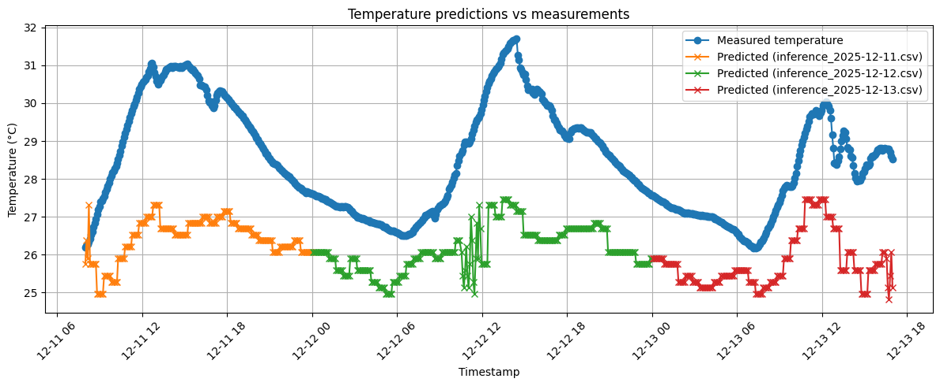

Figure 23: CNN model predictions vs actual measurements

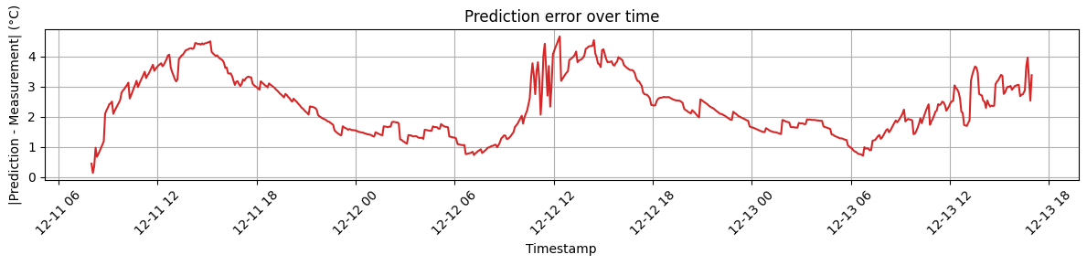

Figure 24: CNN model prediction error

The mean prediction error was found to be 2.4°C, while the median was found to be 2.2°C. The CNN was found to match the pattern of true daily temperatures fairly well; however, all of the predictions consistently underfit the true values. This meant that the errors at cooler times in the day were lower, but the errors peaked when the true temperatures spiked.

Two possible explanations were found for this behaviour. The first is that the temperature data taken for training from the OpenMeteo API was consistently lower than the true temperature measured at the localized site. This is one example of microclimate variation, and is illustrated below. The higher temperatures at the end (from September 2025) represent the collected sensor data.

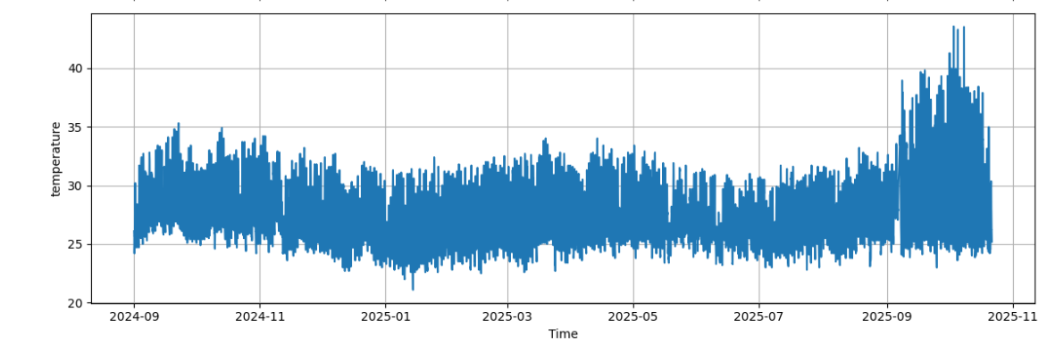

Figure 25: Graph of combined OpenMeteo API temperatures and measured sensor temperatures.

Therefore, with an entire year of training data with these higher temperatures at the site, the model would likely have predicted higher temperatures.

The second explanation is that the range of values used for quantization/dequantization was too low, forcing the models to only predict values within a narrow range. Additional work could be done to expand the quantized range to reflect more accurate temperatures.

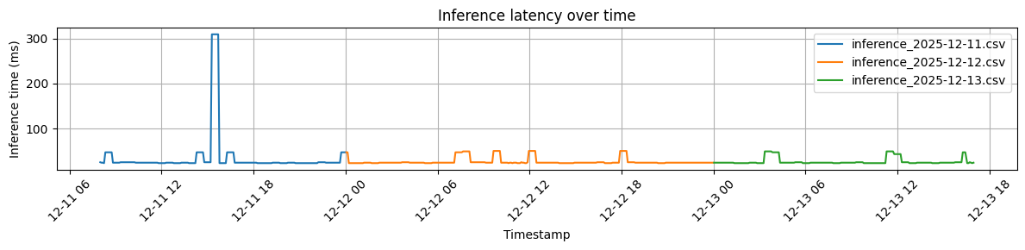

Figure 26: CNN model inference latency

The mean inference latency for the CNN was found to be 30.1 ms, and the median was found to be 25.0ms. The inference latency was relatively low and stable over these 3 days, except for one occurrence when it spiked to >300ms, likely because of contention with another task in the RTOS.

## Recurrent Neural Network

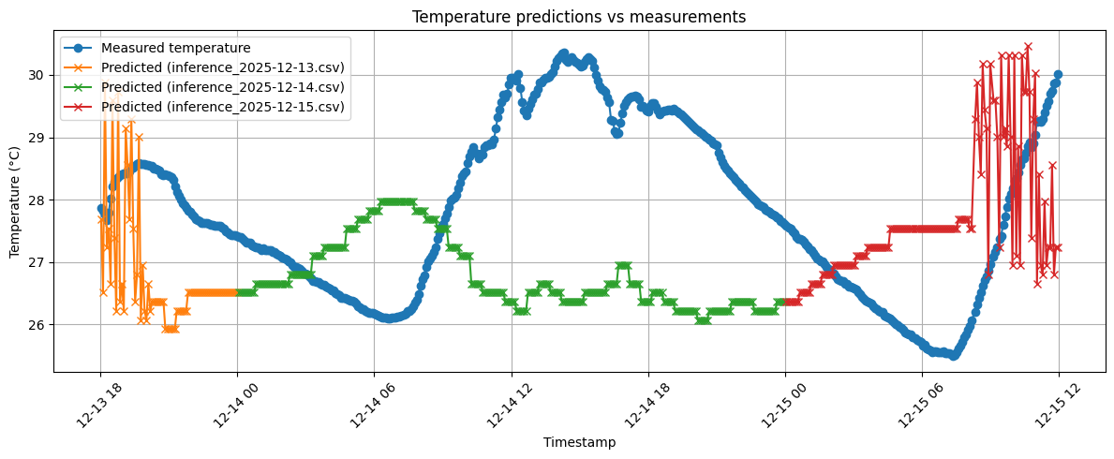

Figure 27: RNN model predictions vs actual measurements

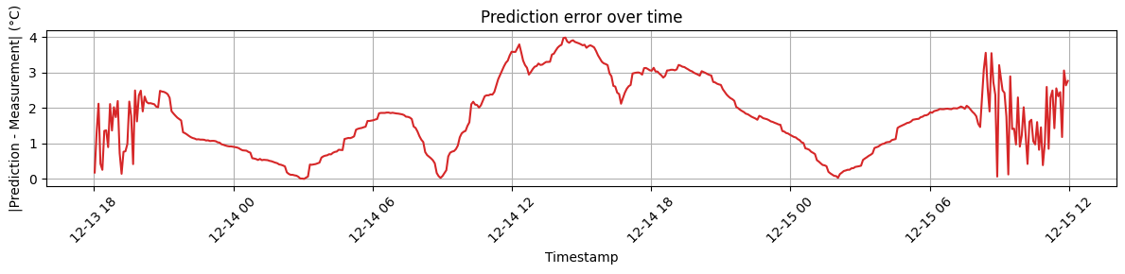

Figure 28: RNN model prediction error

The RNN’s test MAE was 1.63°C initially, increasing slightly to 1.68°C after pruning and to 1.70°C after quantization. Once the model was deployed on-device, it yielded a mean prediction error of 1.8°C and a median error of 1.7°C. RNNs are specifically designed to process time-series and sequential data by maintaining a hidden state that carries information from previous time steps. Therefore, the RNN was able to maintain a robust predictive performance even after aggressive model compression. The RNN’s architecture allowed it to generalize well from training and validation datasets to actual sensor data collected in the field.

Additionally, since RNNs use feedback from previous time steps to inform their current predictions, when the model detects a significant deviation between its forecast and the actual measured temperature, it adjusted its internal state in the subsequent time step in an attempt to compensate for the error in the previous step. This is highlighted by the oscillations of the prediction line in Figure 29.

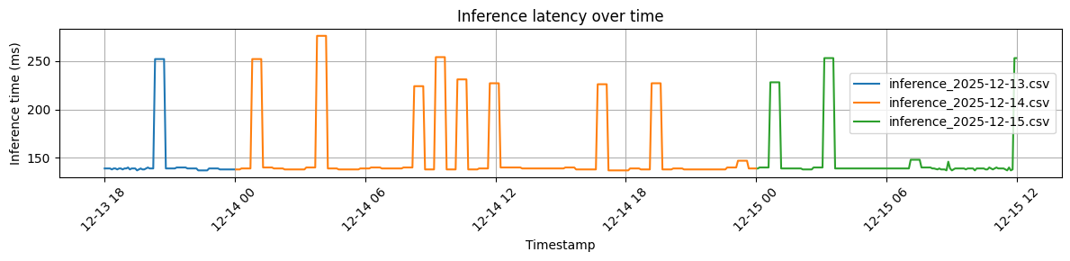

Figure 29: RNN model inference latency

The mean inference latency for the RNN was 152.8 ms, with a median of 139.0 ms, remaining well within the operational requirements for most microclimate forecasting applications.

## Power Measurements

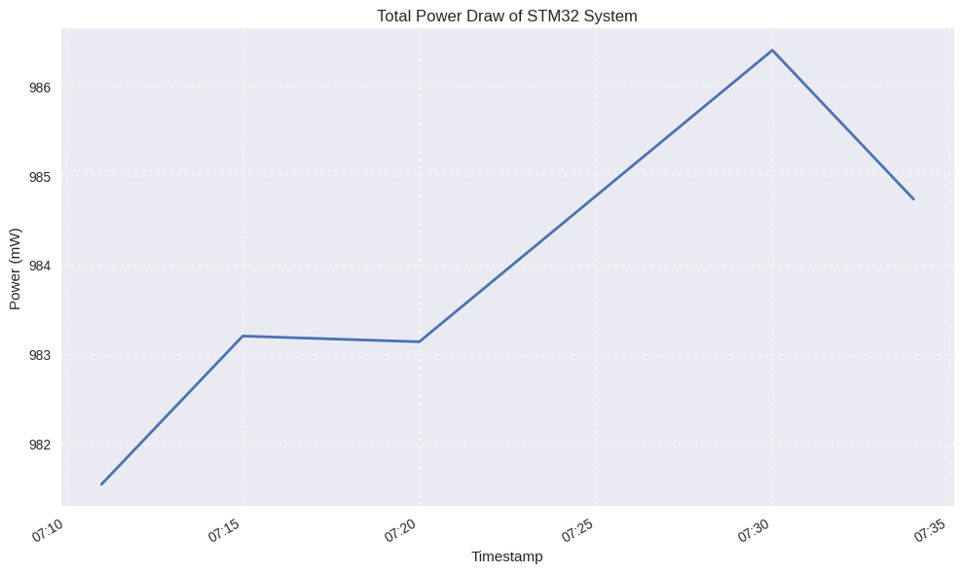

Figure 30: Total system power draw during inference

We saw no significant statistical variation in total power draw for our embedded system during inference with either model. As illustrated in the graph above, power consumption seemed fairly constant across all sampling intervals. Across all samples, we measured a mean of 984mW, and a standard deviation of 1.8mW, meaning that we saw less than a 0.2% variation in total power consumption across all measurements. It is possible that a multimeter with additional measurement capabilities (with automatic, more-frequent sampling and a current scale in the range of mA) would uncover more variations which could be tied to inference.

## Discussion

Both models were deployed successfully to the STM32 board and were able to produce fairly accurate results in spite of the rigorous constraints imposed.

The RNN was found to produce more accurate results (with a lower average prediction error) than the CNN. However, this improved performance came with significant costs in terms of higher inference times and higher model sizes in SRAM.

Depending on the actual embedded system and project requirements, either model could be suitable for use. For example, if the system needed to be constrained to use <100kB of SRAM because of other task requirements, or needed to produce results within 50ms, then the CNN would be the better candidate. On the other hand, if accuracy was the critical parameter, then the RNN would be more suitable.

# **Conclusion And Future Work**

We were able to successfully able to train, tune, prune, quantize and deploy two DNN weather-forecasting models to an STM32 F767 embedded system, and perform inference on the system while capturing true values from sensors on the same board for comparison.

Given the time and hardware limitations required, our final CNN and RNN models performed relatively well and fit easily in the SRAM of the STM32 system. The power required to perform inference on the board was not found to be statistically significant over the baseline power required to operate the regular functions.

We were able to deploy a CNN with a final model size of 30.8 kBs, an average test MAE of 1.4 °C, an average on-device deployment MAE of 2.4°C and an average inference time of 30.1ms.

We were also able to deploy an RNN with a final model size of 80.9 kBs, an average test MAE of 1.7°C, an average on-device deployment MAE of 1.8°C and an average inference time of 152.8ms.

We found that the RNN was able to achieve a lower MAE after deloyment, but required more space in SRAM than the CNN. Therefore, either model could be suitable, depending on the specific hardware requirements of the project.

In order to improve this work further, we would recommend capturing training data over an entire year or more at the intended deployment location of the system, for a much richer and more localised training set.

We would also recommend spending additional time iterating through different model architectures (with extra layers, different quantization ranges etc.) and evaluating the results after deployment. However, care must be taken as many of the optimization functions that exist in modern high-level ML libraries are not supported on low-power embedded systems.

Additionally, we would recommend including more input sensors to enable predictions of additional features in a multi-output model. For example, an anemometer and a puviometer could be added to record input features for wind speed and rainfall amounts respectively.

# **References**

Abadade, Y., Temouden, A., Bamoumen, H., Benamar, N., Chtouki, Y., Hafid, A.S., 2023. A Comprehensive Survey on TinyML. IEEE Access 11, 96892–96922. https://doi.org/10.1109/access.2023.3294111

Ben Bouallègue, Z., Clare, M.C.A., Magnusson, L., Gascón, E., Maier-Gerber, M., Janoušek, M., Rodwell, M., Pinault, F., Dramsch, J.S., Lang, S.T.K., Raoult, B., Rabier, F., Chevallier, M., Sandu, I., Dueben, P., Chantry, M., Pappenberger, F., 2024. The Rise of Data-Driven Weather Forecasting: A First Statistical Assessment of Machine Learning–Based Weather Forecasts in an Operational-Like Context. Bulletin of the American Meteorological Society 105, E864–E883. https://doi.org/10.1175/bams-d-23-0162.1

Cabello-Solorzano, K., Ortigosa de Araujo, I., Peña, M., Correia, L., J. Tallón-Ballesteros, A., 2023. The Impact of Data Normalization on the Accuracy of Machine Learning Algorithms: A Comparative Analysis, in: Lecture Notes in Networks and Systems. Springer Nature Switzerland, Cham, pp. 344–353.

Codeluppi, G., Davoli, L., Ferrari, G., 2021. Forecasting Air Temperature on Edge Devices with Embedded AI. Sensors 21, 3973. https://doi.org/10.3390/s21123973

Copernicus Climate Change Service, Climate Data Store, 2018. ERA5 hourly data on single levels from 1940 to present [WWW Document]. Climate Data Store. URL https://cds.climate.copernicus.eu/doi/10.24381/cds.adbb2d47 (accessed 9.7.25).

de Burgh-Day, C.O., Leeuwenburg, T., 2023. Machine learning for numerical weather and  climate modelling: a review. Geoscientific Model Development 16, 6433–6477. https://doi.org/10.5194/gmd-16-6433-2023

Deutel, M., Woller, P., Mutschler, C., Teich, J., 2022. Energy-efficient Deployment of Deep Learning Applications on Cortex-M based Microcontrollers using Deep Compression [WWW Document]. arXiv.org. URL https://arxiv.org/abs/2205.10369

Diaz-Iglesias, A., Belaunzaran, X., Florez-Tapia, A.M., 2025. Short-Term Power Demand Forecasting for Diverse Consumer Types to Enhance Grid Planning and Synchronisation [WWW Document]. arXiv.org. URL https://arxiv.org/abs/2506.04294

Døskeland, Ø., Gudmestad, O.T., Moen, P., 2023. Use of response forecasting in decision making for weather sensitive offshore construction work. Ocean Engineering 287, 115896. https://doi.org/10.1016/j.oceaneng.2023.115896

Dueben, P.D., Bauer, P., 2018. Challenges and design choices for global weather and climate models based on machine learning. Geoscientific Model Development 11, 3999–4009. https://doi.org/10.5194/gmd-11-3999-2018

Goodfellow, I., Bengio, Y., Courville, A., 2016. Deep Learning. MIT Press.

Guo, Q., He, Z., Wang, Z., 2024. Monthly climate prediction using deep convolutional neural network and long short-term memory. Scientific Reports 14. https://doi.org/10.1038/s41598-024-68906-6

Han, S., Mao, H., Dally, W.J., 2015. Deep Compression: Compressing Deep Neural Networks with Pruning, Trained Quantization and Huffman Coding [WWW Document]. arXiv.org. URL https://arxiv.org/abs/1510.00149

Hasanpour, M.A., Kirkegaard, M., Fafoutis, X., 2025. EdgeMark: An automation and benchmarking system for embedded artificial intelligence tools. Journal of Systems Architecture 167, 103488. https://doi.org/10.1016/j.sysarc.2025.103488

Heydari, S., Mahmoud, Q.H., 2025. Tiny Machine Learning and On-Device Inference: A Survey of Applications, Challenges, and Future Directions. Sensors 25, 3191. https://doi.org/10.3390/s25103191

Immonen, R., Hämäläinen, T., 2022. Tiny Machine Learning for Resource-Constrained Microcontrollers. Journal of Sensors 2022, 1–11. https://doi.org/10.1155/2022/7437023

Jadon, A., Patil, A., Jadon, S., 2024. A Comprehensive Survey of Regression-Based Loss Functions for Time Series Forecasting, in: Lecture Notes in Networks and Systems. Springer Nature Singapore, Singapore, pp. 117–147.

Kelemen, M., Miková, Ľ., Hroncová, D., Filakovský, F., Sinčák, P.J., 2020. EMBEDDED SYSTEMS – CONTROL OF POWER SUBSYSTEMS. Acta Mechatronica 5, 23–28. https://doi.org/10.22306/am.v5i2.64

Kumar, P., Chandra, R., Bansal, C., Kalyanaraman, S., Ganu, T., Grant, M., 2021. Micro-climate Prediction - Multi Scale Encoder-decoder based Deep Learning Framework, in: Proceedings of the 27th ACM SIGKDD Conference on Knowledge Discovery &amp; Data Mining. ACM, New York, NY, USA, pp. 3128–3138.

Lara-Benítez, P., Carranza-García, M., Riquelme, J.C., 2021. An Experimental Review on Deep Learning Architectures for Time Series Forecasting. International Journal of Neural Systems 31, 2130001. https://doi.org/10.1142/s0129065721300011

Morales-García, J., Bueno-Crespo, A., Martínez-España, R., Posadas, J.-L., Manzoni, P., Cecilia, J.M., 2023a. Evaluation of low-power devices for smart greenhouse development. The Journal of Supercomputing 79, 10277–10299. https://doi.org/10.1007/s11227-023-05076-8

Morales-García, J., Bueno-Crespo, A., Martínez-España, R., Posadas, J.-L., Manzoni, P., Cecilia, J.M., 2023b. Evaluation of low-power devices for smart greenhouse development. The Journal of Supercomputing 79, 10277–10299. https://doi.org/10.1007/s11227-023-05076-8

Naseer, I., Akram, S., Masood, T., Jaffar, A., Khan, M.A., Mosavi, A., 2022. Performance Analysis of State-of-the-Art CNN Architectures for LUNA16. Sensors 22, 4426. https://doi.org/10.3390/s22124426

OpenMeteo API [WWW Document], 2025. . Open-Meteo.com. URL https://open-meteo.com/ (accessed 12.19.25).

Osman, A., Abid, U., Gemma, L., Perotto, M., Brunelli, D., 2022. TinyML Platforms Benchmarking, in: Lecture Notes in Electrical Engineering. Springer International Publishing, Cham, pp. 139–148.

Perumal, T., Mustapha, N., Mohamed, R., Shiri, F.M., 2024. A Comprehensive Overview and Comparative Analysis on Deep Learning Models. Journal on Artificial Intelligence 6, 301–360. https://doi.org/10.32604/jai.2024.054314

Prudden, R., Adams, S., Kangin, D., Robinson, N., Ravuri, S., Mohamed, S., Arribas, A., 2020. A review of radar-based nowcasting of precipitation and applicable machine learning techniques [WWW Document]. arXiv.org. URL https://arxiv.org/abs/2005.04988?utm_source=chatgpt.com

Rumelhart, D.E., Hinton, G.E., Williams, R.J., 1986. Learning representations by back-propagating errors. Nature 323, 533–536. https://doi.org/10.1038/323533a0

Shen, D., Zhao, X., Chai, L., Guo, Z., Leng, C., 2024. Analysis of the agricultural economic value of a weather forecasting service based on a survey of peasant households in Chinese provinces. Humanities and Social Sciences Communications 11. https://doi.org/10.1057/s41599-024-02685-3

Shiri, F.M., Perumal, T., Mustapha, N., Mohamed, R., 2023. A Comprehensive Overview and Comparative Analysis on Deep Learning Models: CNN, RNN, LSTM, GRU [WWW Document]. arXiv.org. URL https://arxiv.org/abs/2305.17473

ST Edge AI Developer Cloud [WWW Document], 2023. . STMicroelectronics - STM32 AI. URL https://stm32ai.st.com/st-edge-ai-developer-cloud/ (accessed 10.7.25).

Sze, V., Chen, Y.-H., Yang, T.-J., Emer, J.S., 2017. Efficient Processing of Deep Neural Networks: A Tutorial and Survey. Proceedings of the IEEE 105, 2295–2329. https://doi.org/10.1109/jproc.2017.2761740

Warden, P., Situnayake, D., 2019. TinyML: Machine Learning with TensorFlow Lite on Arduino and Ultra-Low-Power Microcontrollers. O’Reilly Media.